## **Objectives**

* Explain about React forms
* Define controlled components
* Explain about various input controls
* Explain about handling forms
* Explain about submitting forms

In this hands-on lab, you will learn how to:

* Implement React forms
* Use various input controls like textbox, button and textarea

## **Prerequisites**

The following is required to complete this hands-on lab:

* Node.js
* NPM
* Visual Studio Code

## **Notes**

Estimated time to complete this lab: **60 minutes.**

Create a React App named “ticketraisingapp” which will help to raise a complaint and get it resolved.

Create a component named “ComplaintRegister” with a form containing a textbox to enter the employee name and a textarea to enter the complaint. Use “handleSubmit” event of the button to submit the complaint and generate a Reference number for further follow ups in the alert box.

**Output Expected:**

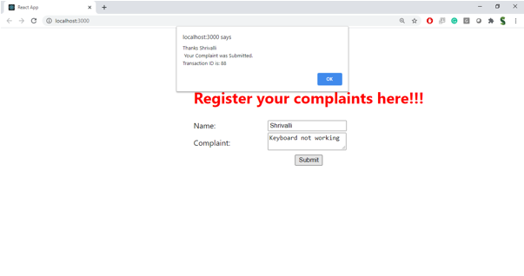

**Hint:**

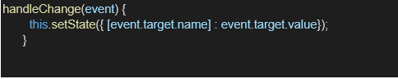

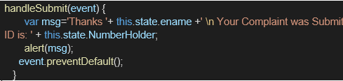

**Output:**

